**Company web application:**

“Company” is web-application which allows users to get, post, update and delete information about departments and employees of the company Global Pharma Trade LLC.

The application provides:

* Information about company;
* Storing information of department and employees of the company in a database;
* Display a list of departments and the average salary (calculated automatically) for these departments
* Updating the list of departments (adding, editing, removing);
* Display list of employees;
* Updating the list of employees (adding, editing, removing);
* Search employees born on a certain date or in the period between dates;
* All the pages of web application have navigation bar for quick access to different pages and functions of the application.
* API rest service

# Home page

Contain information about the company.



Pic. 1.1. Home page.

# 2. Departments

## 2.1. Display list of departments

Page is designed to view the list of department and the average salary (calculated automatically) for these departments

*Main scenario:*

* User selects hyperlink “Departments” in the navigation of any page of the application;
* Application displays list of Departments with names of departments ( hyperlinks to the page of the current department ) and average annual salary of all the employees of the current department. If no employees were added to the department annual salary of the department equal 0.

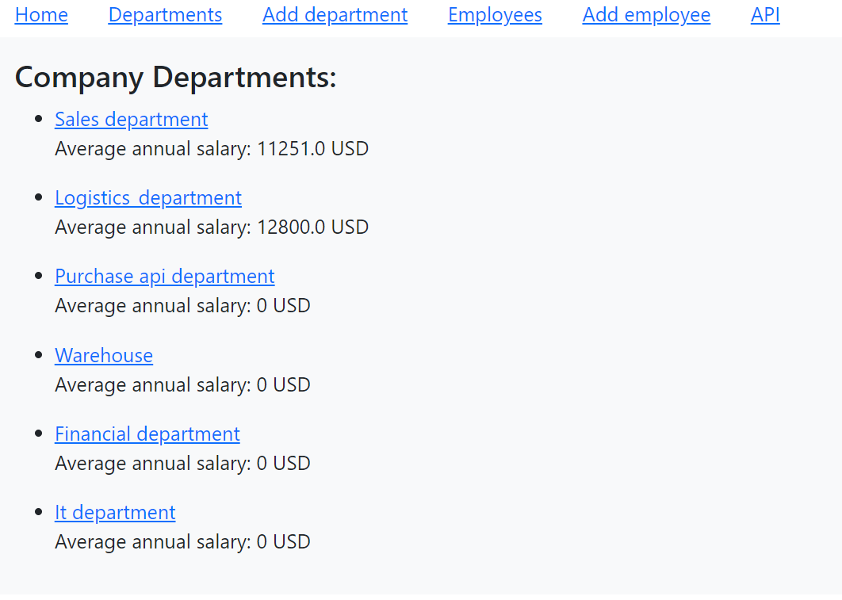

Pic. 2.1 View the Deparments list.

## 2.2. Page of current department.

Page is designed to view name of department, it’s description, uuid, average annual salary, list of the employees of the department, their annual salary. There are 3 additional links: Add employee, Update department, Delete department.

*Main scenario:*

* User selects hyperlink with department name in the page “Departments”;
* Application displays the page of chosen Department.

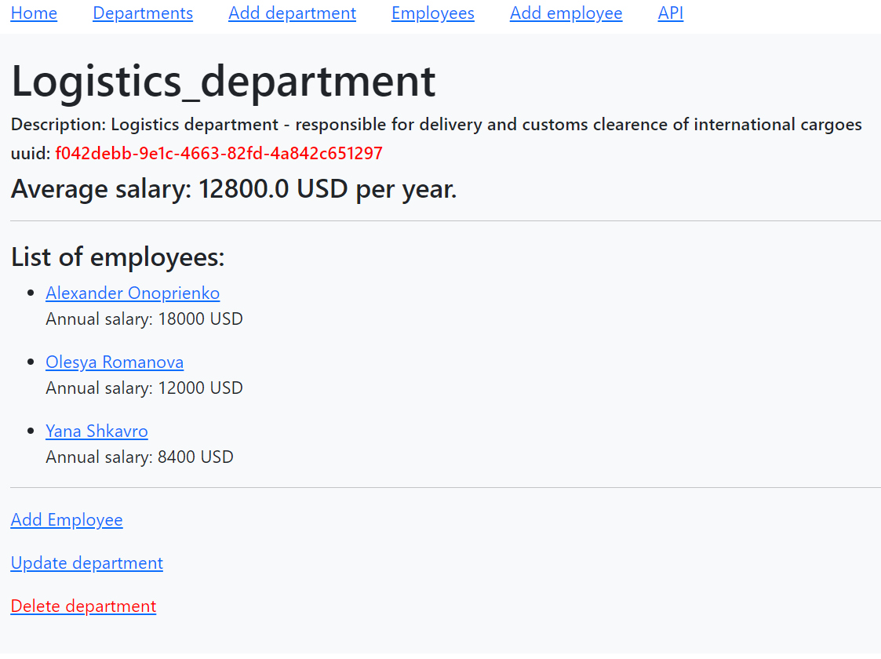

Pic. 2.2 sample of deparments page.

## 2.3. Add department.

### Main scenario:

* + - User clicks “Add department” hyper link in the nav bar of any page;
    - Application displays form to enter department data. The form has a “submit” button 2 fields:

1. “name” is a mandatory field,
2. “description is an optional field

       

* + - User enters department data and presses “Submit” button;
    - then the department is adding to database;
    - If new department is successfully added, then page of the created deparment and message – “Department created successfully” is displaying

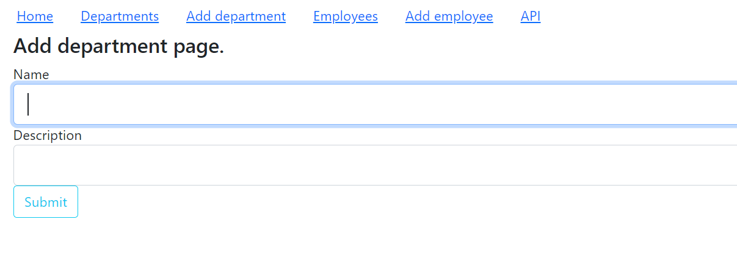

Pic. 2.3 Add department page

Constraints for data validation:

* + - Department name – maximum length of 120 characters;
    - Description is optional field. Can be left empty

## 2.4. Update department.

### Main scenario:

* + - User clicks “Update department” hyper link in the page of current department;
    - Application displays form to enter department data. The form has a “submit” button 2 fields:

1. “name” is a mandatory field,
2. “description is an optional field
   * +   Fields name and description are already have contain information of the current department and these field are acceptable for edition.
     + User edits department data and presses “Submit” button;
     + If the department is successfully updated, then page of the edited deparment and message – “Department updated successfully” is displaying

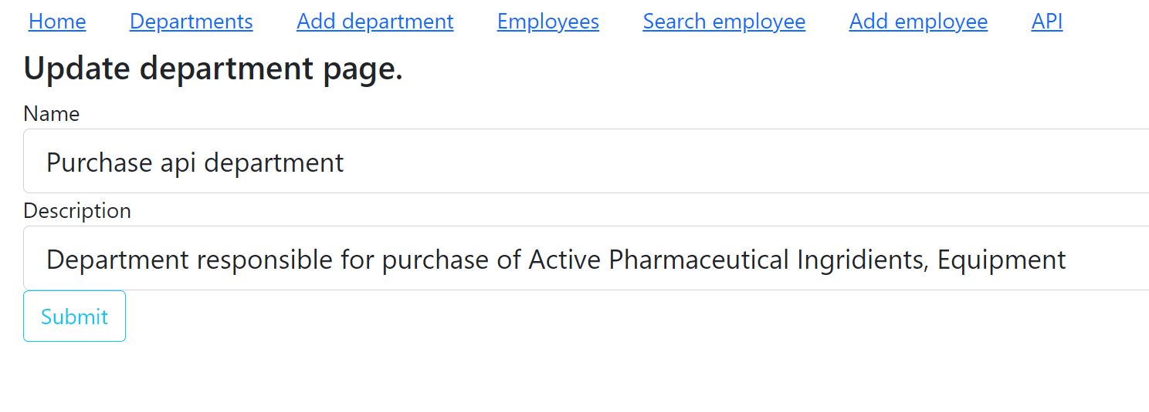

Pic. 2.4 Update department page

Constraints for data validation:

* + - Department name – maximum length of 120 characters;
    - Description is optional field. Can be left empty.

## Removing the department.

### Main scenario:

* + - User clicks “Delete department” hyper link in the page of current department;
    - It is possible to delete a department ONLY if there are no employees in the department. So before delete the department it is necessary to delete all employees from the department or update their department before removing the department.
    - If the user tries to delete the department with the employees it is still in the page of the current department, but the message “ You cannot delete department with the employees” is displaying:

### 

Pic. 2.5. Departement page if user tries to delete department with employees.

* + - If the department can be removed the record is deleted from database;
    - then list of departments without deleted department and message “ department deleted successfully” is displaying.

# 3. Employees

## 3.1. Display list of departments

Page is designed to view the list of Employees and the annual salary for every employee and search employees born on a certain date or in the period between dates.

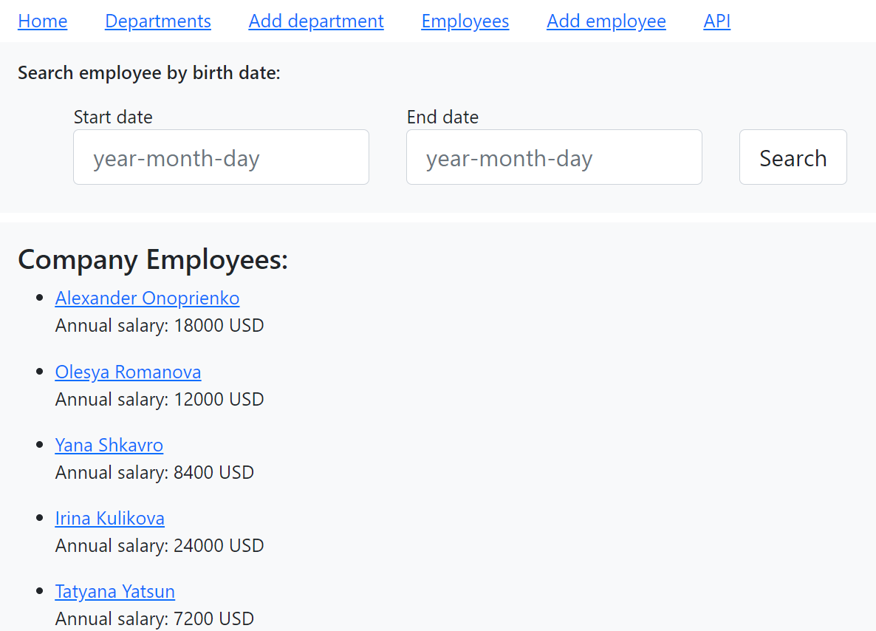

Pic. 3.1.1. Page Employees.

*Main scenario:*

* + - User selects item “Employees” in the navigation of any page of the application;
    - Application displays list of employees with names of employee ( hyperlink to the page of the current employee ) and annual salary the current employees.
    - The page contains form for search employee search employees born on a certain date or in the period between dates. The form has a “Search” button and 2 fields:

1. “Start date” is a mandatory field ( only format “year-month-day” is acceptable)
2. “End date is an optional field ( only format “year-month-day” is acceptable)
   * + The user may input only start date and search the employees that were born exactly on the input date or the user may input start and end dates and search for the employees that were born in the period between dates ( start date and end date).
     + User enters data and presses “Search” button;
     + Then page of with search result is displaying.

## 

Pic. 3.1.2. Page Search results.

## 3.2. Page of current employee.

Page is designed to view name of the current employee, his/her birth date, annual salary, deparment name ( hyperlink to the department page)

There are 3 additional links: Department name, Update employee, Delete employee.

*Main scenario:*

* User selects hyperlink with employee name in the page “Employees”, in the page “Department”;
* Application displays the page of chosen Employee.

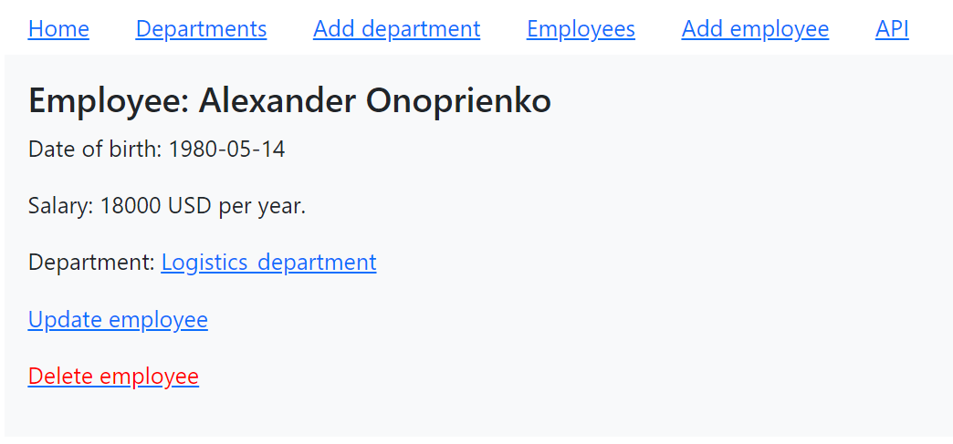

Pic. 3.2. sample of Employee page

## 3.3. Add employee.

### Main scenario:

* User clicks “Add employee” hyper link in the nav bar of any page or on the department page;
* Application displays form to enter employee data. The form has a “submit” button 4 fields:

1. “Employee_name”,
2. “Birth_date,
3. “Salary”
4. “Department_uuid”

       

* User enters emplpoyee data and presses “Submit” button;
* then the employee is adding to database;
* If new employee is successfully added, then page of the created employee and the message “ Employee created successfully” is displaying.
* Id and uuid of the employee are generated automatically.

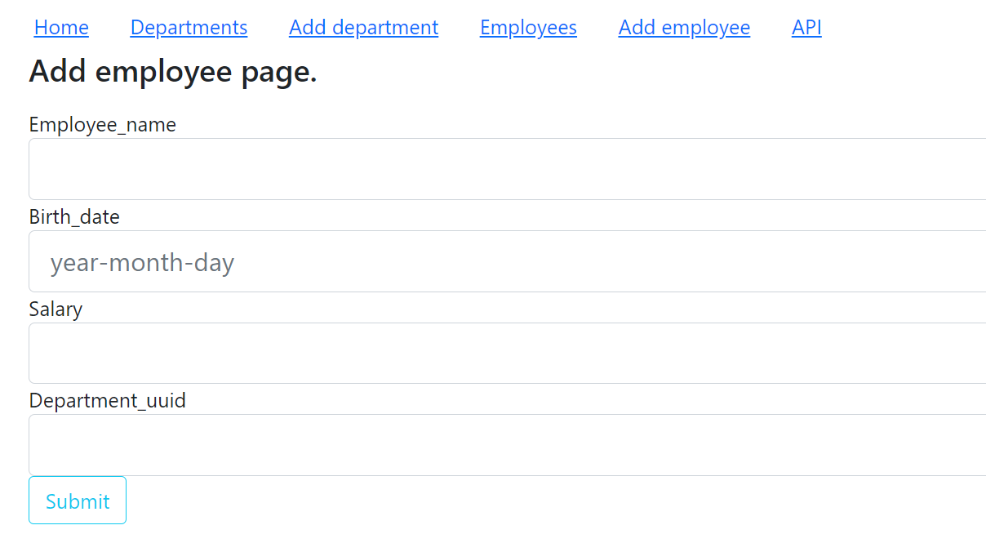

Pic. 3.3 Add employee page

Constraints for data validation:

* employee_name – maximum length of 120 characters;
* birth_date – format year/month/day
* salary - integer
* department_uuid - must comply with the uuid of the existing department of the company.
* If the user input incorrect department date message “input the correct uuid of the department” is displaying.

## 3.4. Update employee.

### Main scenario:

* User clicks “Update employee” hyper link in the page of current employee;
* Application displays form to enter employee data. The form has a “submit” button 4 fields:

1. “name”,
2. “birth_date,
3. Salary
4. Department_uuid
   * +   All fields are already have contain information of the current employee and these field are acceptable for edition.
     + User edits employee data and presses “Submit” button;
     + If the employee is successfully updated, then page of the edited employee is displaying.

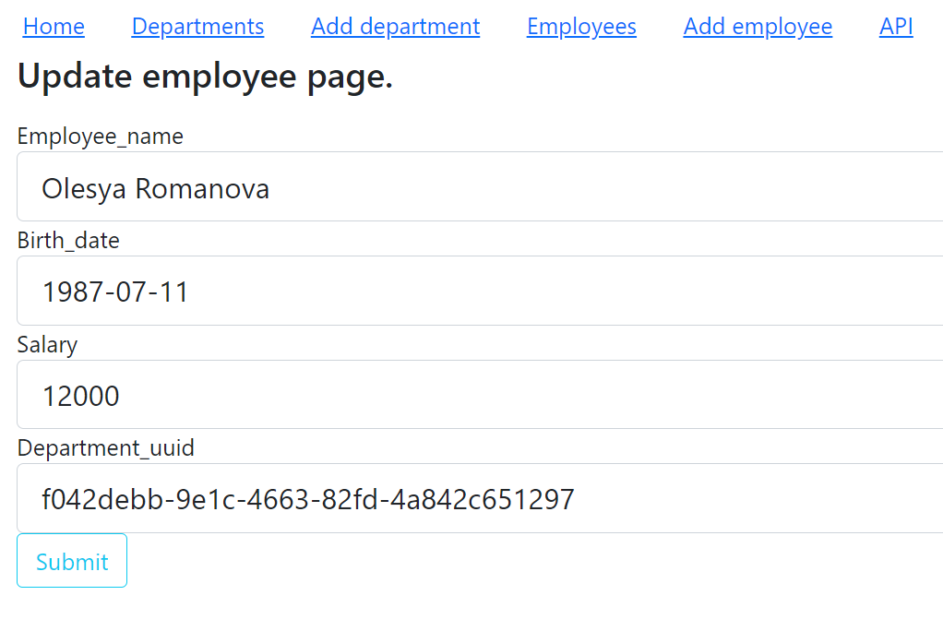

Pic. 3.4 Update department page

Constraints for data validation:

* + - employee_name – maximum length of 120 characters;
    - birth_date – format year/month/day
    - salary - integer
    - department_uuid - must comply with the uuid of the existing department of the company
    - If the user input incorrect department date message “input the correct uuid of the department” is displaying.

## 3.5. Removing employee.

### Main scenario:

* + - User clicks “Delete employee” hyper link in the page of current employee;
    - If the department can be removed the record is deleted from database;
    - then the user redirects to the list of the employees and message “employee deleted successfully” is displaying.